Practical 3
Part A
1) | Distinct points (Point.java + Driver.java with main)  (a) Create class Point with private int x, y and a constructor.  (b) Override toString() to return “(x, y)”.  (c) Override equals(Object) to be true when both x and y match, and hashCode() to agree  (e.g. Objects.hash(x, y)).  (d) In Driver.main: build a Point[] with some repeated coordinates.  (e) Count distinct points: for each point, use equals() to check whether it already  appeared earlier; count those that did not.  (f) Print “Distinct: N”.
 | Point.java
Code | import java.util.Objects;  public class Point {  private int x, y;  Point(int x, int y) { this.x = x; this.y = y; }  public String toString() { return "(" + x + ", " + y + ")"; }  public boolean equals(Object o) {  if (!(o instanceof Point p)) { return false; }  return x == p.x && y == p.y;  }  public int hashCode() { return Objects.hash(x, y); }  }
 | Driver.java
Code | public class Driver {  public static void main(String[] args) {  Point[] points = {new Point(1,2), new Point(3,4), new Point(1,2),  new Point(5,6), new Point(3,4)};  int count = 0;  for (int i = 0; i < points.length; i++) {  boolean found = false;  for (int j = 0; j < i; j++) {  if (points[i].equals(points[j])) { found = true; break; }  }  if (!found) { count++; }  }  System.out.println("Distinct: " + count);  }  }
Output | 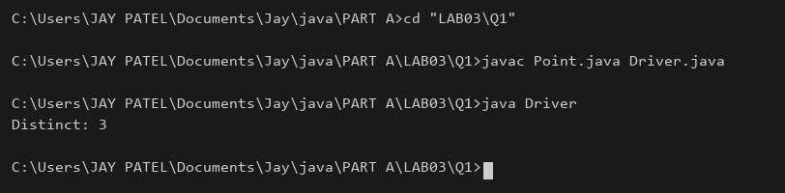

2) | Duplicate card check (Card.java + Driver.java)  (a) Create class Card with private String rank, suit and a constructor.  (b) Override toString() to return rank + “ of ” + suit (e.g. “Queen of Hearts”).  (c) Override equals()/hashCode() by rank + suit.  (d) In Driver.main: add cards to a Card[] one at a time; before adding each, use equals()  to check it against the earlier cards.  (e) Print “Duplicate found: <card>” the first time a repeat appears.
 | Card.java
Code | import java.util.Objects;  public class Card {  private String rank, suit;  Card(String rank, String suit) { this.rank = rank; this.suit = suit; }  public String toString() { return rank + " of " + suit; }  public boolean equals(Object o) {  if (!(o instanceof Card c)) { return false; }  return rank.equals(c.rank) && suit.equals(c.suit);  }  public int hashCode() { return Objects.hash(rank, suit); }  }
 | Driver.java
Code | public class Driver {  public static void main(String[] args) {  Card[] input = {new Card("Ace", "Spades"), new Card("Queen", "Hearts"),  new Card("Ace", "Spades")};  Card[] cards = new Card[input.length];  int size = 0;  for (Card c : input) {  boolean duplicate = false;  for (int i = 0; i < size; i++) {  if (c.equals(cards[i])) { duplicate = true; break; }  }  if (duplicate) {  System.out.println("Duplicate found: " + c); break;  }  cards[size++] = c;  }  }  }
Output | 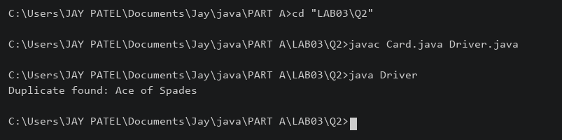

3) | (For Advanced Learners – home) Fractions (Fraction.java + Driver.java)  (a) Create class Fraction with private int num, den.  (b) In the constructor, reduce to lowest terms: compute g = gcd(num, den) and divide  both by g.  (c) Override toString() to return num + “/” + den.  (d) Override equals()/hashCode() using the reduced num and den.  (e) In Driver.main: create several equivalent fractions (1/2, 2/4, 3/6) and confirm they  are all equal and print the same.
 | Fraction.java
Code | import java.util.Objects;  public class Fraction {  private int num, den;  Fraction(int num, int den) {  if (den == 0) { throw new IllegalArgumentException("Zero denominator"); }  if (den < 0) { num = -num; den = -den; }  int g = gcd(Math.abs(num), den);  this.num = num / g; this.den = den / g;  }  private int gcd(int a, int b) {  while (b != 0) { int t = a % b; a = b; b = t; }  return a;  }  public String toString() { return num + "/" + den; }  public boolean equals(Object o) {  if (!(o instanceof Fraction f)) { return false; }  return num == f.num && den == f.den;  }  public int hashCode() { return Objects.hash(num, den); }  }
 | Driver.java
Code | public class Driver {  public static void main(String[] args) {  Fraction a = new Fraction(1, 2);  Fraction b = new Fraction(2, 4);  Fraction c = new Fraction(3, 6);  System.out.println(a + " " + b + " " + c);  System.out.println(a.equals(b) && b.equals(c));  }  }
Output | 

